Artisan Local Vegetarian/Vegan Product of the Year Entry Form
Closing date for entries: 10th May 2024
This category is open to products which are actively promoted/marketed as being suitable for vegetarians or vegans. Please see terms and conditions for further information.

1. Artisan Product Vegetarian/Vegan Name and Description:
Product Name
(as it appears on the label/at point of sale)
Please describe your product in no more than 40 words (please note, this description may be used in publicity material, were you to be successful in being shortlisted):

2. Business Contact Details:
This is how your business will appear throughout judging and in publicity material, were you to be successful in being shortlisted).
Business Name
Contact Name
Position
Business Address (Inc. postcode)
Entry Telephone Number
Entry Mobile Number
Business Phone Number (for public use)
Email
Website
Twitter/FB/Instagram
Reg. Company No.

3. My artisan vegetarian/vegan product is:
- Grown or reared and supplied from a farm in Northamptonshire
- Made using raw materials produced, grown or reared in Northamptonshire
- Made in a production facility within Northamptonshire
- Suitable for vegetarians
- Suitable for vegans

4. My Business:
 | YES | NO
- My registered business headquarters are in Northamptonshire

5. Brief history of the artisan vegetarian/vegan product
Tell us a bit about the history of the product (in no more than 250 words)

6. Where do the different elements of production take place?
Do the following elements of production happen in Northamptonshire? | YES | NO
- Recipe creation
- Packaging design
- Manufacture (please indicate in the box below if any part of the manufacturing process takes place
outside Northamptonshire)
- Bottling
- Labelling
- Other (please specify below)

If the answer to any of the above (No. 6) is ‘NO’, please indicate the reason why it does not occur in Northamptonshire; there may be a very good reason why not!

7. Pricing
Please explain why your entry represents good value for money. Please give details of the cost as sold to the public e.g. per kilo / unit etc.

8. Local suppliers
Please give a list of your local suppliers who supply you with any of your ingredients, where appropriate; a local supplier is one which is based within Northamptonshire or within 30 miles of your production facility in Northamptonshire. If you do not use local suppliers or locally made ingredients, please say why not (there might be a
very good reason!)

9. Local retailers
Please give a list of places that currently sell your product (both in Northamptonshire and beyond)

10. Allergen information
Please detail your level of food allergy awareness, explain the methods you have in place and the records you keep to identify the allergens in your product, and in addition to providing a copy of the label for the product, please therefore submit any supporting information which you use to make your customers aware of potential allergen
hazards.

11. Sustainability
Our headline sponsor Weetabix has developed a ‘Change For Better’ framework, based on the four key areas listed in the boxes below. You can read the full report here: https://www.weetabix.co.uk/sustainability/
Please provide examples, and evidence where appropriate, of your current initiatives across any (or all) of the following areas, or indicate plans you have in place. (If any of the areas does not apply to you/your business, please insert N/A)

a. Sustainable ingredients
b. Reducing packaging waste
c. Efficient operations
d. Health and Wellbeing
e. Any other examples of sustainability not covered by the areas above

12. Supporting Information
Please provide your supporting information that you feel is useful for judges to know. (It is not limited to the area you can see). Alternatively, you may provide up to ten sides of A4 containing other information in support of your entry. If you wish us to refer to your internet site, please provide printed copies of up to five key pages (but this comes out of your allocation of ten additional pages). However, we cannot return any material.

Data Protection
By entering the Awards, you agree for us to store your details on our database and for us to contact you regarding all matters relating to the Awards. The database is accessed only by the Awards team and will not be shared with third parties, unless stated. If we are working with a partner whose work we believe may be of interest to you, we might share their information with you. If you would prefer not to be sent additional information by email, please let us know. You can be removed from the Awards database at any time – please just email: awards@northamptonshirefoodanddrink.co.uk with UNSUBSCRIBE in the subject box and your name and contact details in the email.

Declarations
 | YES | NO
The details provided on this form and all supporting evidence are correct to the best of my knowledge and are submitted in accordance with the published Weetabix
Northamptonshire Food and Drink Awards 2024/25 rules.
I agree to the details of my entry being passed to the category sponsors, to Trading Standards and my local Council’s Environmental Health Department.
I authorise that my details may be subject to checks with Trading Standards and my local Council’s Environmental Health Department to disclose to the organisers and judges of Northamptonshire Food and Drink Awards any relevant significant history, complaints, or
breaches of relevant Regulations or law.
This product is available to purchase at the time of the category closing date of 10th May 2024 and is reasonably expected to remain on sale until after 1 January 2025.
I agree to provide samples free of charge for the shortlisting and, if shortlisted, the final judging. These samples will be “as supplied to the public” / “as sold” and will not be modified or enhanced in any way.
If shortlisted, I agree to provide up to 100 further tasting samples of the product free of charge for a public tasting event. (If you feel you cannot do this but would still like to enter,
please discuss it with Rachel prior to, or at the time of, submission of entry)
I agree to participate in awards-related publicity
If successful in securing ‘Gold’, I agree to my product being entered into the Great Taste Awards 2025 (entry fee will be paid by Weetabix Northamptonshire Food and Drink Awards) but for which I will provide samples for judging (see details below)
Neither I nor anyone connected with my company has attempted to or will attempt to influence the organisers, judges, or promoter, or in any way bring the Awards into disrepute.
I confirm that this entry complies with the letter and the spirit of the rules of the competition.
I’m happy to receive emails relating to Food and Drink in Northamptonshire, including the Weetabix Northamptonshire Food and Drink Awards.
By entering, I am ‘opting-in’ to the Awards contacts database
Please send me emails about my entry into this competition only

By typing/signing your name below, you are certifying that all the details submitted are correct to the best of your knowledge.

Signed |  | Date
Entries can be submitted by hand, post or emailed. All supporting information and postal entries should be returned to: The Mallows Company, Arch Villa, 23 High Street, Bozeat, Northamptonshire, NN29 7NF Tel: 01933 664437
Email entries to: awards@northamptonshirefoodanddrink.co.uk

You will receive an email confirming safe receipt of your entry – whether that is submitted by email or post.

Artisan Local Vegetarian/Vegan Product of the Year Entry
Entries will be verified by the organisers to ensure compliance with the Terms and Conditions, and with the spirit of the
Awards. Organisers will use their best efforts to assist all entrants to comply with the Terms and Conditions but cannot be held responsible if for any reason an entry has to be disqualified or rejected. Details of entries will be passed to Trading Standards Department and the relevant local council’s Environmental Health Department to disclose to the organisers and judges any relevant significant history, complaints, or breaches of relevant Regulations or law. The organisers will determine what action to take as a result of any such disclosure.

Longlisting
A panel of local judges will sample all entries and select between 12 and 16 products to go forward for the shortlisting. The panel will make its decision based on the following criteria:-

Taste, aroma and visual appeal
- Traceability and origin including:-
  - Is it made using local ingredients wherever possible, and is that evidenced?
  - Is the Northamptonshire origin of the product mentioned/celebrated on the packaging/advertising?
  - Ways in which the producer tackling issues of sustainability
- Promotion, including:-
  - Promotion of the product
  - Appearance and presentation
  - Packaging, including labelling
  - Value for money
- Compliance including:-
  - Any advice received from Trading Standards Department and the relevant local Council’s Environment Health Department
Each entrant will then be advised whether they have been selected as a longlisted.

Shortlisting
A panel of local judges will select their finalists from the longlist, again using the criteria above. Each longlisted entrant will then be advised if they have been shortlisted as a finalist.

Expert Panel
Our expert, external judges will taste and rate the samples. Those scores and the results of the previous judging will be used to determine who should be awarded Gold, Silver or Bronze. The results will be announced at the Awards Dinner of which all finalists will receive one free ticket (maximum of one free ticket per company, irrespective of number of categories entered). Post Awards Gold Award winners will be invited to Business mentoring. The organisers and judges will use the following guideline marking scheme:-

Taste and aroma  Traceability and origin Promotion | 50%
 | 30%
 | 20%

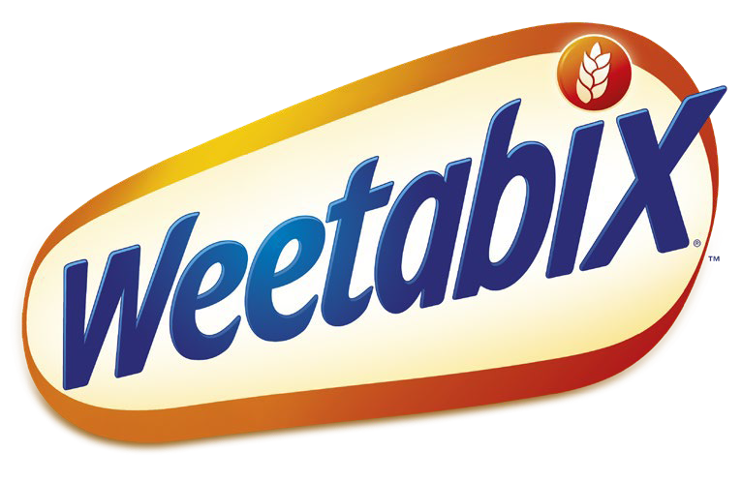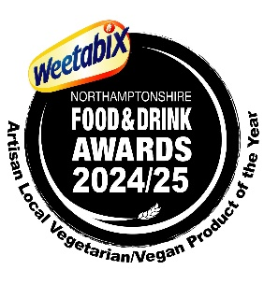

Key Dates

Closing Date Shortlisting Final Judging
Awards Dinner

10th May 2024
5th June 2024
9th July 2024
17th October 2024
Finalists will receive one free ticket to the Awards Dinner with a nominal charge of £25 for the second ticket
and subsequent tickets will be charged at the higher rate.

Great Taste Awards 2025
If you are successful in being awarded ‘Gold’ in the category, your product will be entered into the Great Taste Awards 2025. The Awards will pay for the cost of that entry (in 2023 that was from £45 plus VAT, depending on company turnover) but for which you will be asked to supply a small number/amount of samples for judging.

Publicity
Please note, the details of those entries which were not successful in being shortlisted will not be made public; only the details of the finalists (and subsequently those awarded Gold, Silver or Bronze) will be made public via our promotional material and via the Awards website – www.northamptonshirefoodanddrink.co.uk
You can also follow the Awards on Twitter and Instagram at @foodawardsHQ or on Facebook at @foodawards or on LinkedIn at @weetabixnfadawards

