Community Café of the Year Entry Form

Closing date – 21st June 2024

This category is open to cafés/tea rooms in Northamptonshire who are not only a great café but are an integral part of the community. Please see terms and conditions for further information.

1. Business Contact Details
This is how your business will appear throughout judging and in publicity material, were you to be successful in being shortlisted).
Business Name
Reg. company number
Contact Name
Position
Business Address inc Postcode
Entrant Telephone No
Entrant Mobile No
Business Tel No
Email
Website
Twitter/FB/Instagram
Opening dates (if not all year round) and hours
Maximum covers

2. Type of venue entered
To make sure that you entering the category correctly, please tick the appropriate following statements. Tick all that apply. This entry relates to a café/tea room which:-
- Is independent of a major chain
- Is part of a small, local chain (no more than six outlets)
- Is part of a larger visitor attraction (e.g. country park, stately home etc)
- Is a community café (i.e. serves a community in Northamptonshire)

Data Protection
By entering the Awards, you agree for us to store your details on our database and for us to contact you regarding all matters relating to the Awards. The database is accessed only by the Awards team and will not be shared with third parties, unless stated. If we are working with a partner whose work we believe may be of interest to you, we might share their information with you. If you would prefer not to be sent additional information by email, please let us know. You can be removed from the Awards database at any time – please just email awards@northamptonshirefoodanddrink.co.uk with UNSUBSCRIBE in the subject box and your name and contact details in the email.

See awards Terms and Conditions for further information.

Declarations | Yes | No
The details provided on this form and all supporting evidence are correct to the best of my knowledge and are submitted in accordance with the published Northamptonshire Food & Drink Awards 2024/25 rules.
I agree to the details of my entry being passed to the category sponsors, to Trading Standards and my local council’s Environmental Health Department.
I confirm the venue holds a Food Hygiene Rating Scheme score of 4 (Good) or above.
I authorise that my details may be subject to checks with Trading Standards and my local Council’s Environmental Health Department to disclose to the organisers and judges of Northamptonshire Food & Drink Awards any relevant significant history, complaints, or breaches of relevant Regulations or law.
If shortlisted, you may be asked to provide (up to) four ‘meals’ free of charge for the second stage of Mystery Shopping (see T&Cs for more details).
I agree to participate in awards-related publicity.
Neither I nor anyone connected with my company has attempted to or will attempt to influence the organizers, judges, or promoters, or in any way bring the Awards into disrepute.
I confirm this entry complies with the letter and spirit of the rules of the competition.
I’m happy to receive emails relating to Food and Drink in Northamptonshire, including the Weetabix Northamptonshire Food and Drink Awards
By entering, I am ‘opting-in’ to the Awards contacts database
Please send me emails about my entry into this competition only.

By typing/signing your name below, you are certifying that all the details submitted are correct to the best of your knowledge.
Signed: |  | Date:
Entries can be submitted by hand, post or emailed. All supporting information and postal entries should be returned to: The Mallows Company, Arch Villa, 23 High Street, Bozeat, Northamptonshire, NN29 7NF Tel: 01933 664437
Email entries to: awards@northamptonshirefoodanddrink.co.uk

You will receive an email confirming safe receipt of your entry – whether that is submitted by email or post.

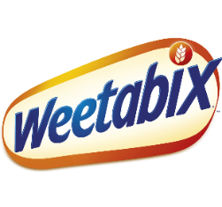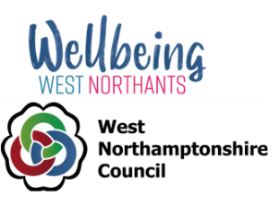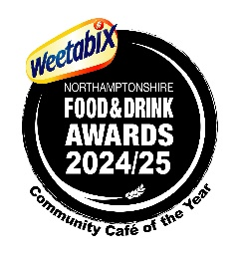
Key Dates

Closing date for registering Mystery Shopping – stage 1 Shortlisting
Mystery Shopping – stage 2

Final Judging

Awards Dinner
21st June 2024

June/July 2024
19th July 2024
August/September 2024

24th September 2024

17th October 2024
Finalists will receive one free ticket to the Awards Dinner with a nominal charge of £25 for the second ticket
and subsequent tickets will be charged at the higher rate.

Publicity
Please note, the details of those entries which were not successful in being shortlisted will not be made public; only the details of the finalists (and subsequently the results of the second stage Mystery Shopping) will be made public via our promotional material and via the Awards ’website – www.northamptonshirefoodanddrink.co.uk

The results will be announced at the Awards Dinner of which all finalists will receive one free tickets (maximum of one free ticket per company, irrespective of number of categories entered). Post Awards Gold Award winners will be invited to Business mentoring.

You can also follow the Awards on Twitter and Instagram at @foodawardsHQ or on Facebook at @foodawards or on LinkedIn at @weetabixnfadawards

